**AI Development Assignment 1 – Screenshots**

# **Task 1 – State Operation**

## **State – Idle**

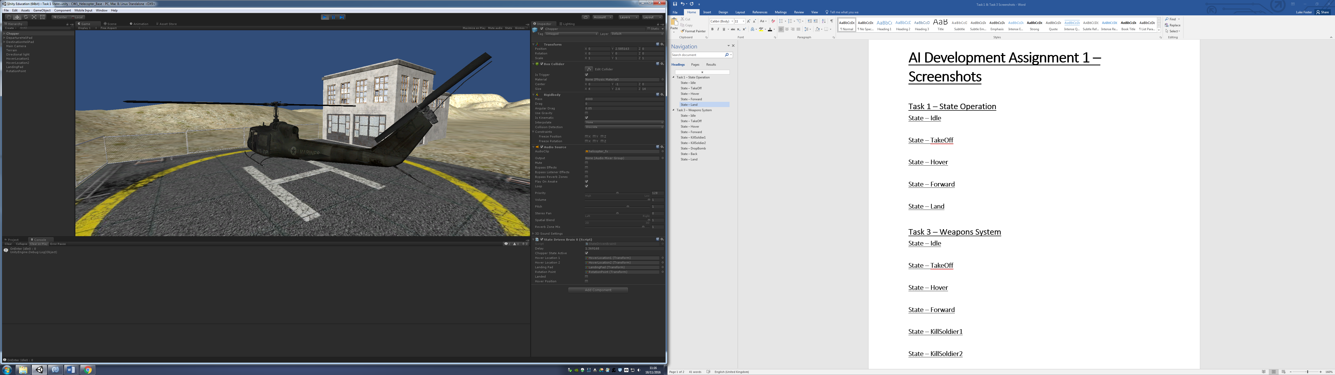

## **State – TakeOff**

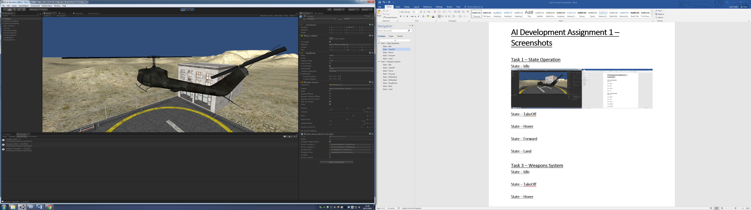

## **State – Hover**

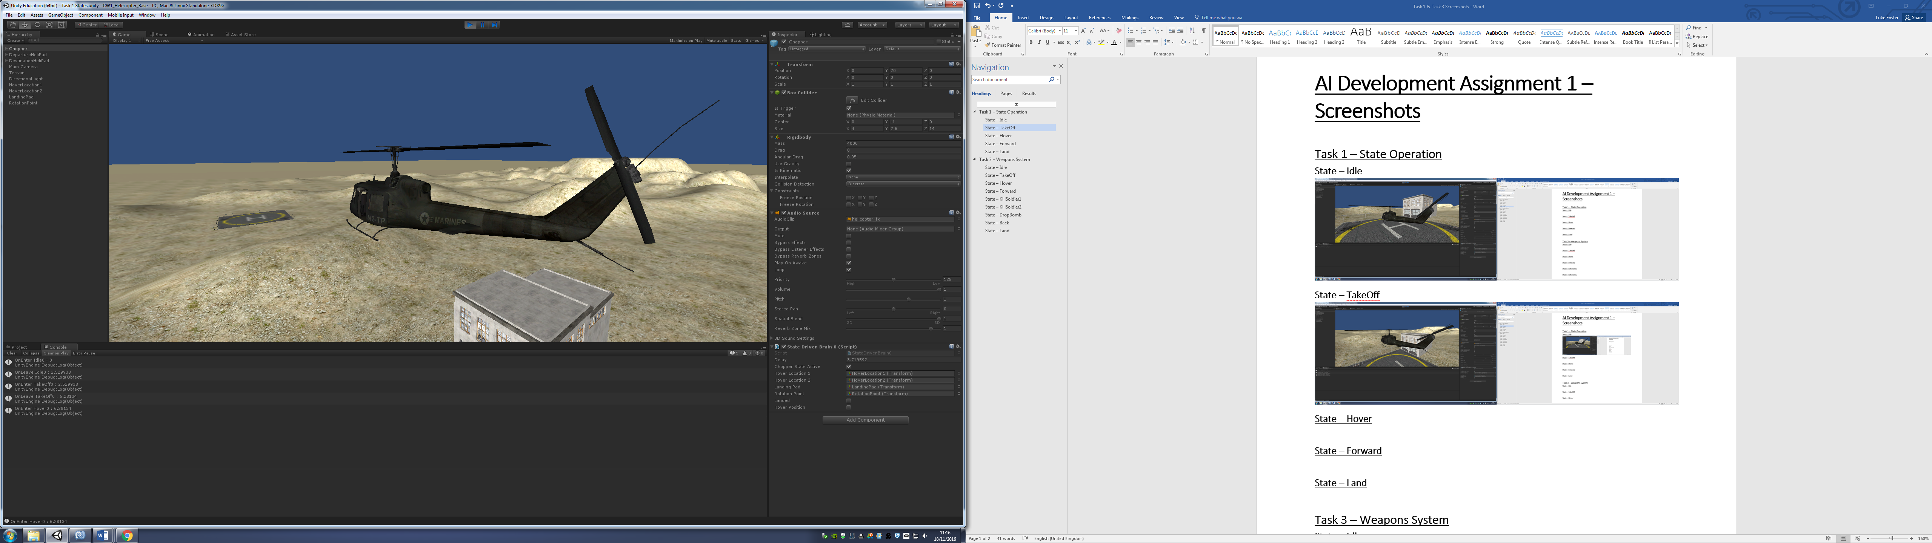

## **State – Forward**

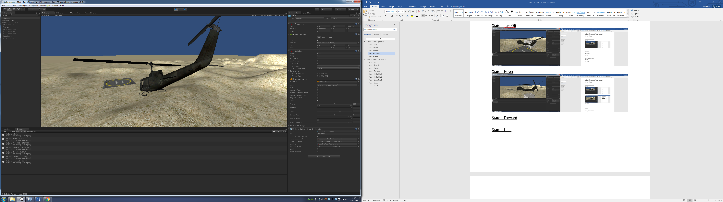

## **State – Land**

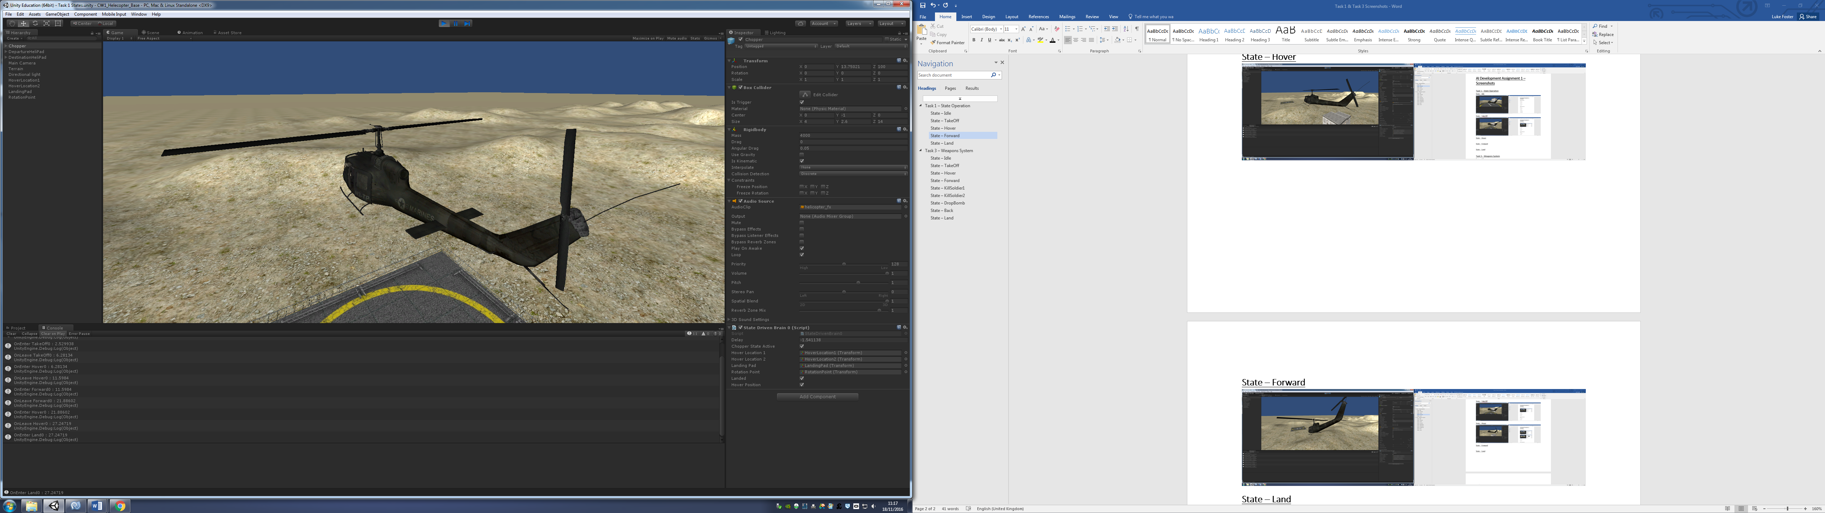

# **Task 3 – Weapons System**

## **State – Idle**

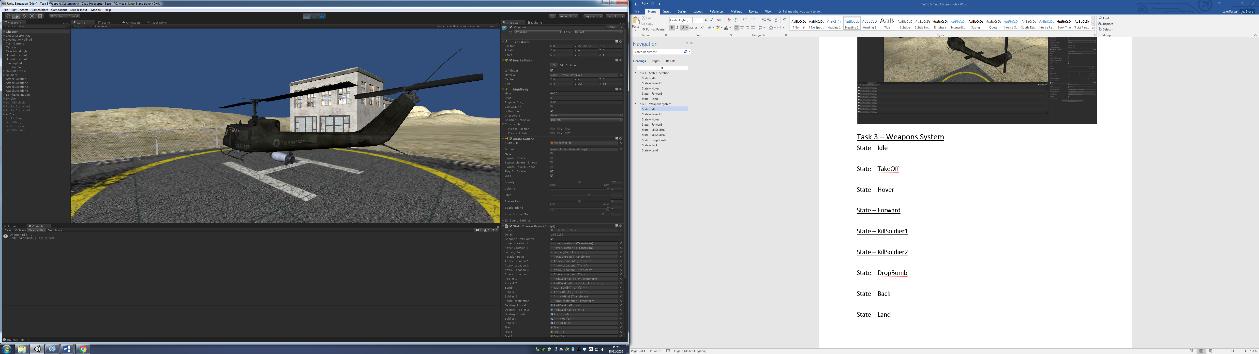

## **State – TakeOff**

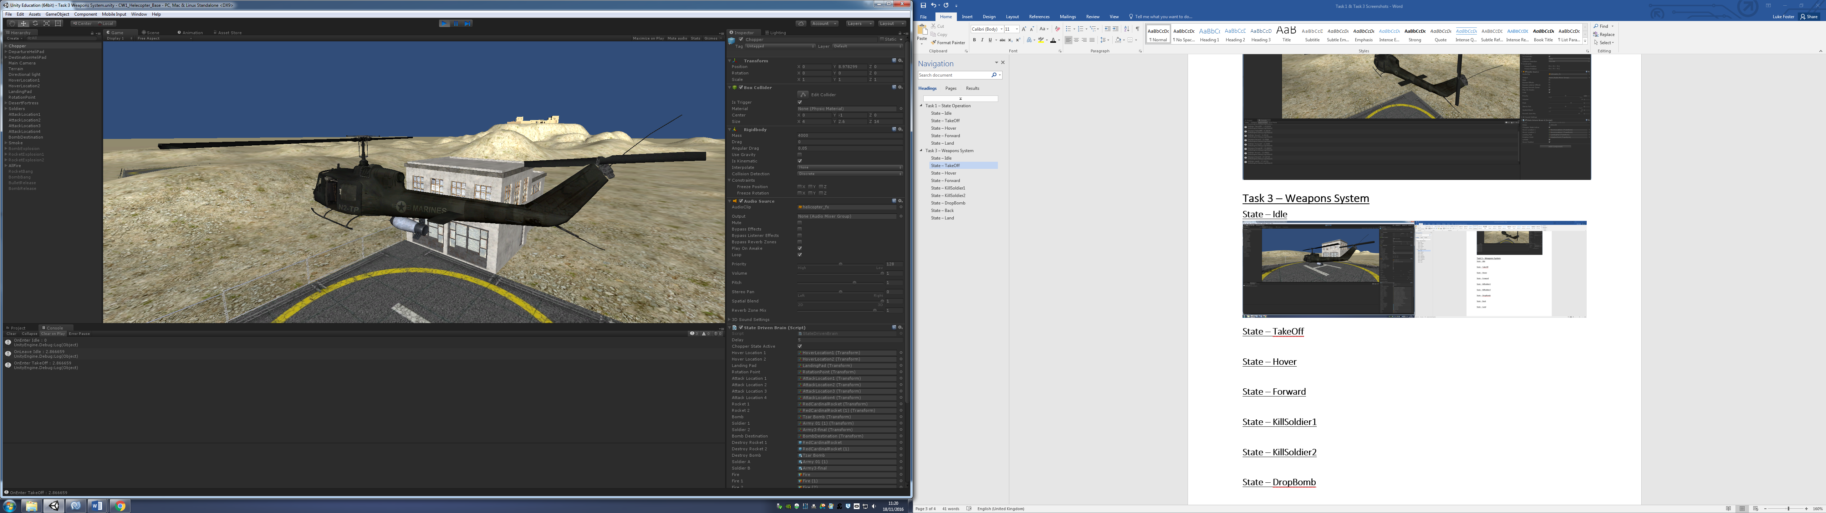

## **State – Hover**

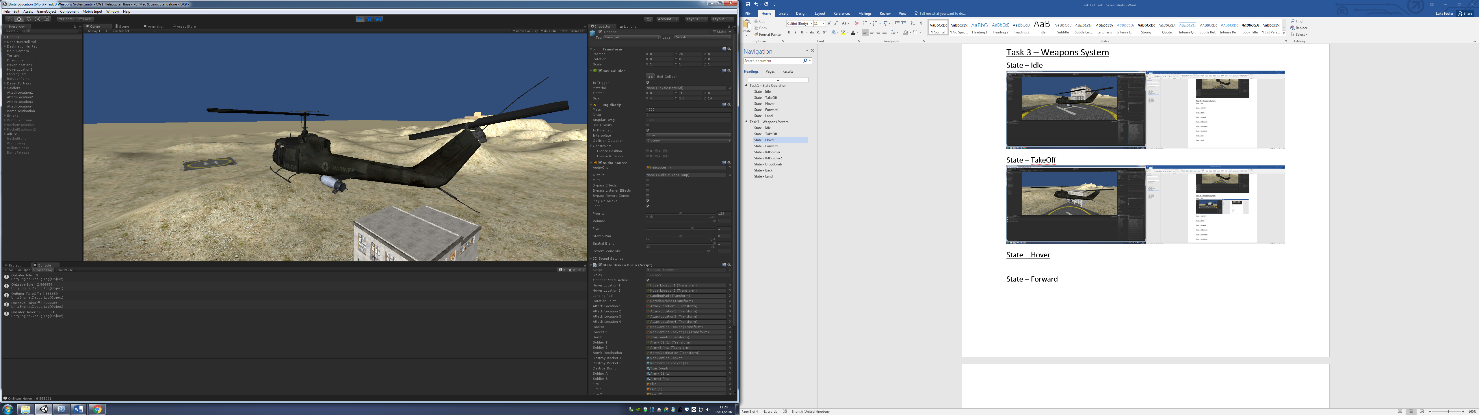

## **State – Forward**

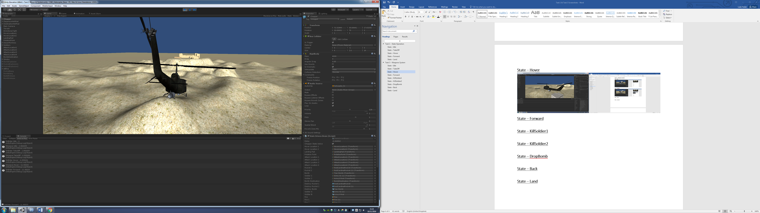

## **State – KillSoldier1**

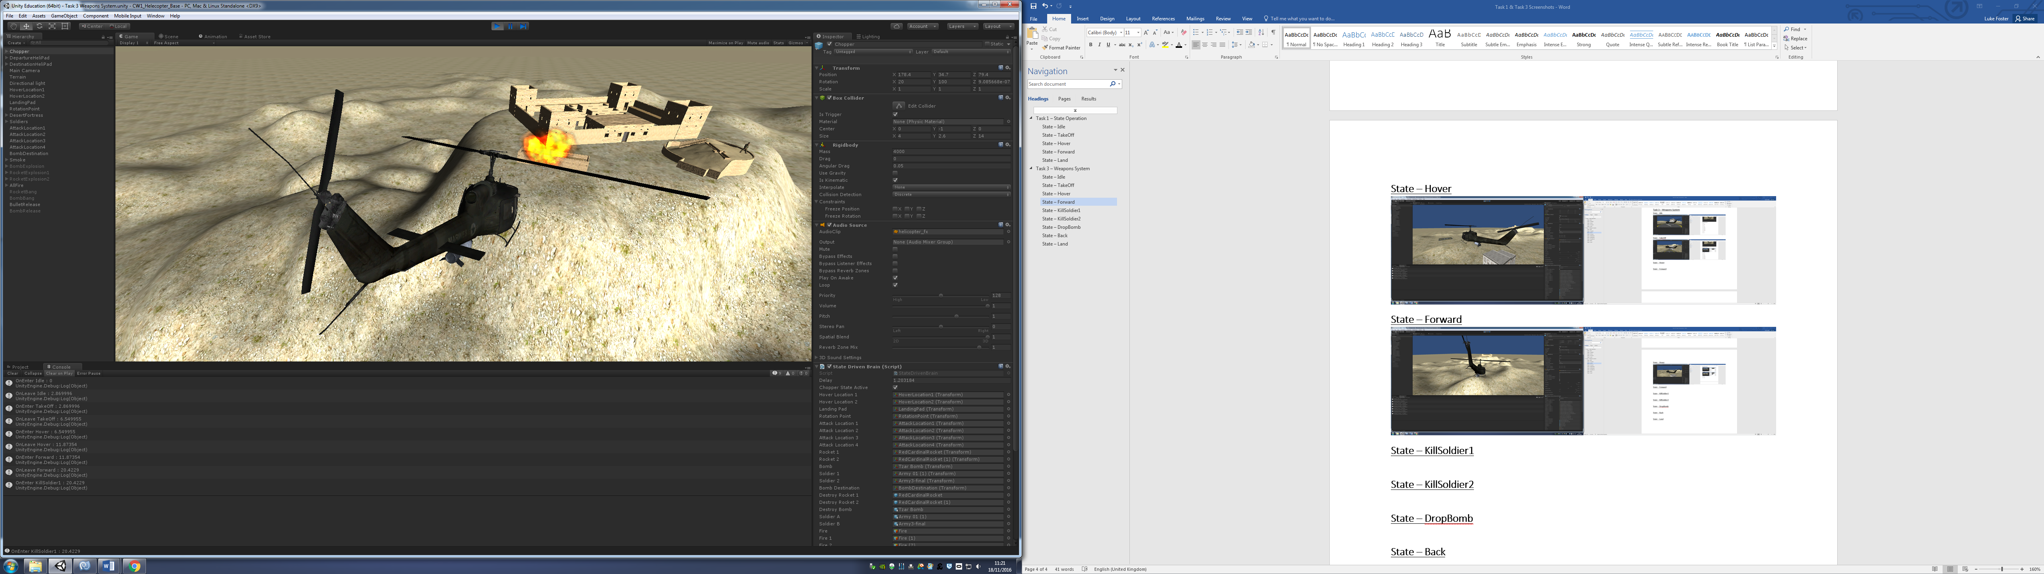

## **State – KillSoldier2**

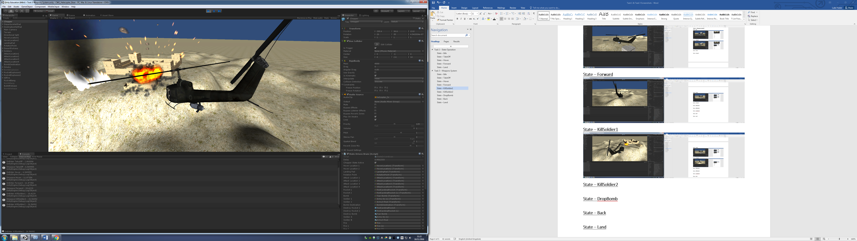

## **State – DropBomb**

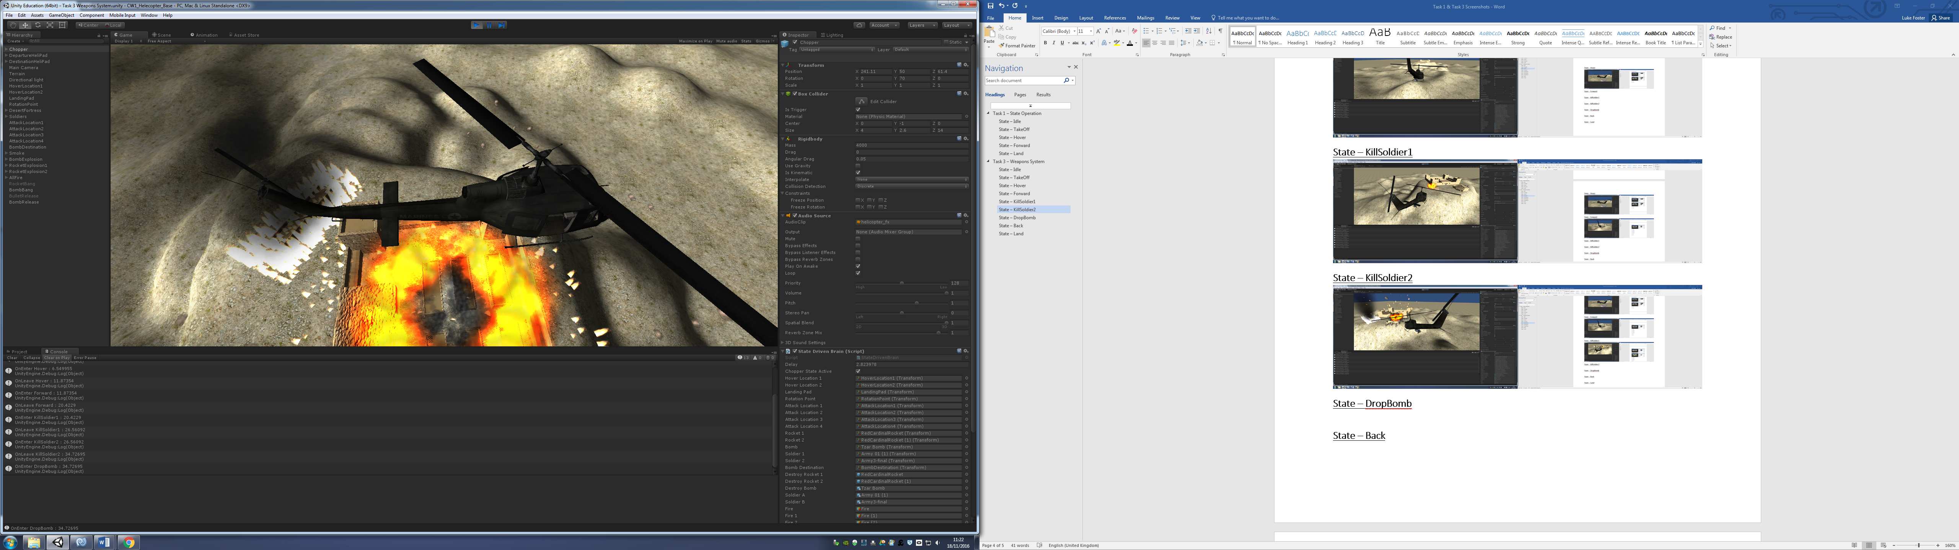

## **State – Back**

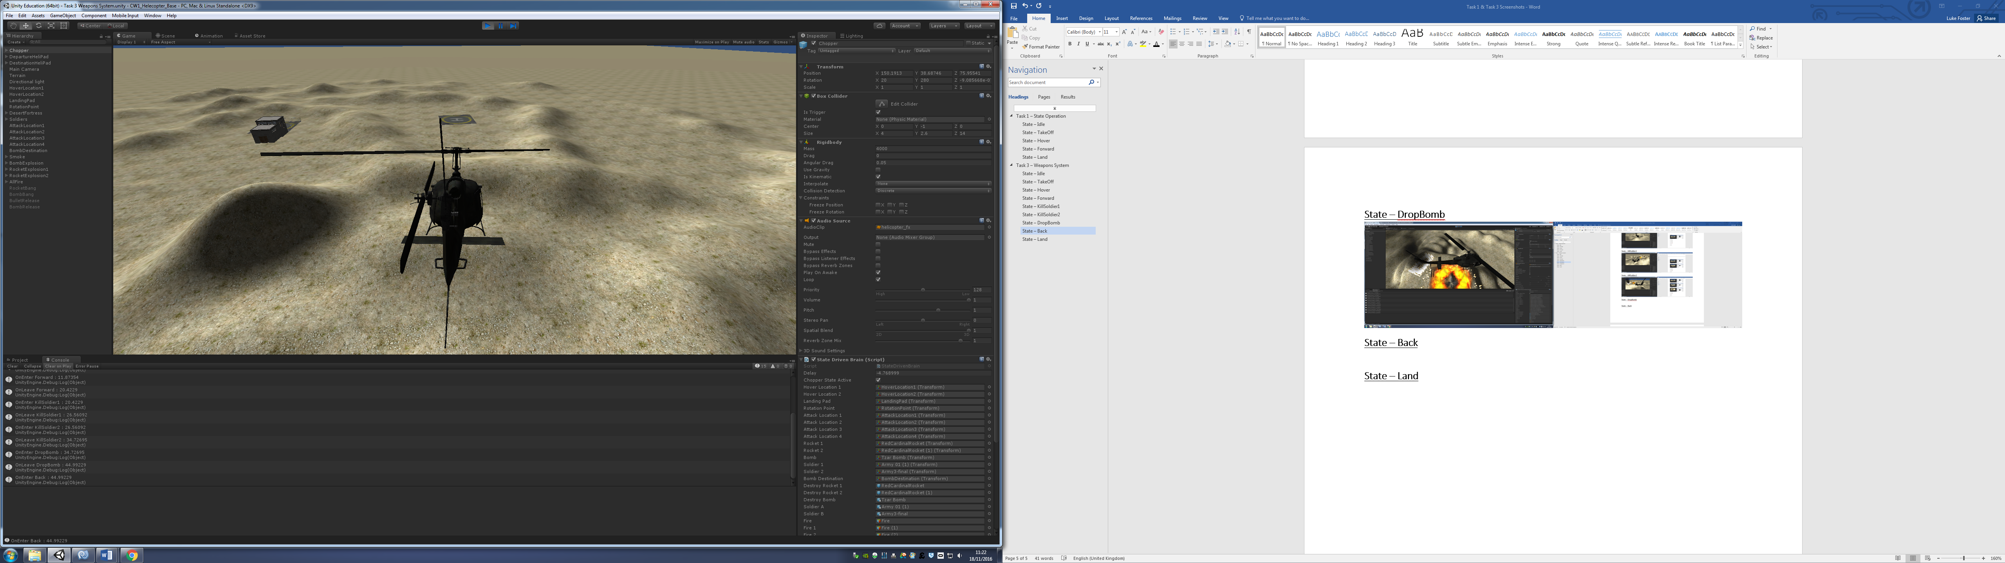

## **State – Land**

